Project Design Phase-II
Data Flow Diagram & User Stories

Date | 18 Jan 2026
Team ID | LTVIP2026TMIDS64924
Project Name | Smart sorting
Maximum Marks | 4 Marks

Data Flow Diagrams:
A Data Flow Diagram (DFD) is a traditional visual representation of the information flows within a system. A neat and clear DFD can depict the right amount of the system requirement graphically. It shows how data enters and leaves the system, what changes the information, and where data is stored.

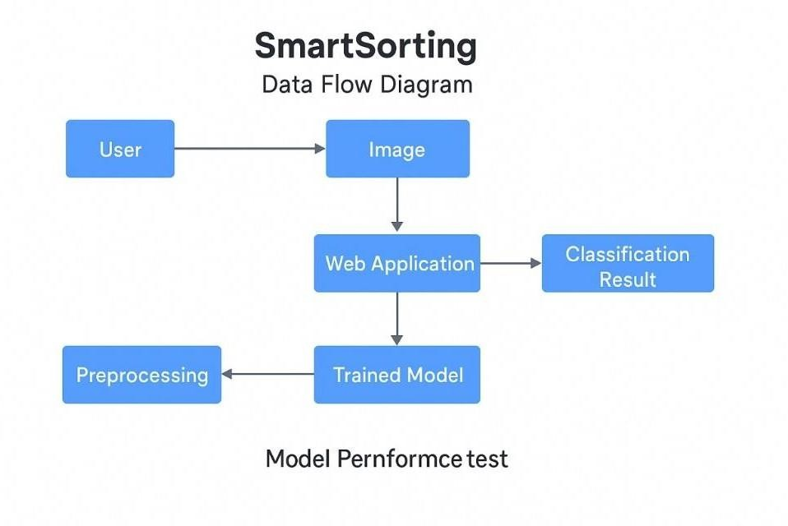

User Stories

User Type | Functional  Requirement  (Epic) | User Story  Number | User Story / Task | Acceptance criteria | Priority | Release
Customer (Web user) | Image Upload | USN-1 | As a user, I can upload an image of a fruit or vegetable | I can select an image and see a preview before submitting | High | Sprint-1
Customer (Web user) | Classification Result | USN-2 | As a user, I can see whether the fruit/vegetable is fresh or rotten | I receive the result immediately after uploading | High | Sprint-1
Customer (Web user) | Confidence Score | USN-3 | As a user, I can view the confidence level of the prediction | A percentage (e.g., 92%) is displayed with the prediction | Medium | Sprint-2
Customer (Web user) | Error Handling | USN-4 | As a user, I get a proper error message if the uploaded file is invalid | An error message appears when unsupported files are uploaded | Medium | Sprint-2
Customer (Web user) | UI Enhancement | USN-5 | As a user, I experience a clean and responsive interface | The web UI adjusts properly across screen sizes | Medium | Sprint-3
Customer (Web user) | Result Log (Local) | USN-6 | As a user, I can view a list of my last uploaded images and results | Session-based history is available for review | Low | Sprint-3
Administrator | Usage Monitoring | USN-7 | As an admin, I can track total number of predictions made | I can see system usage statistics (optional future scope) | Low | Future

